**NOTES ON ANIMATOR’S SAMPLE STANDING GR FROM 10-30-21-OT IN NECESSARY ORDER DISCUSSION**

1. HAT

1. Vajra top added
2. Vulture feather added to vajra
3. Banners-*2 up flowing-Lt & Rt from shoulders removed*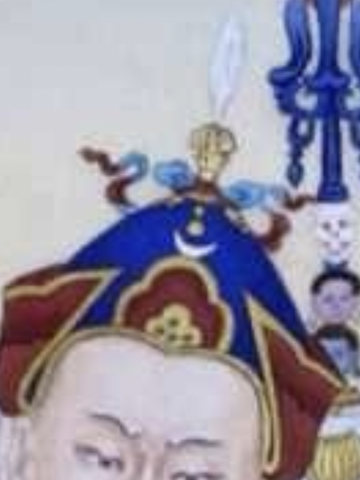
4. Blue top *part of hat as seen in above photo*

2. Add KHATVANGA under arm/in *left* arm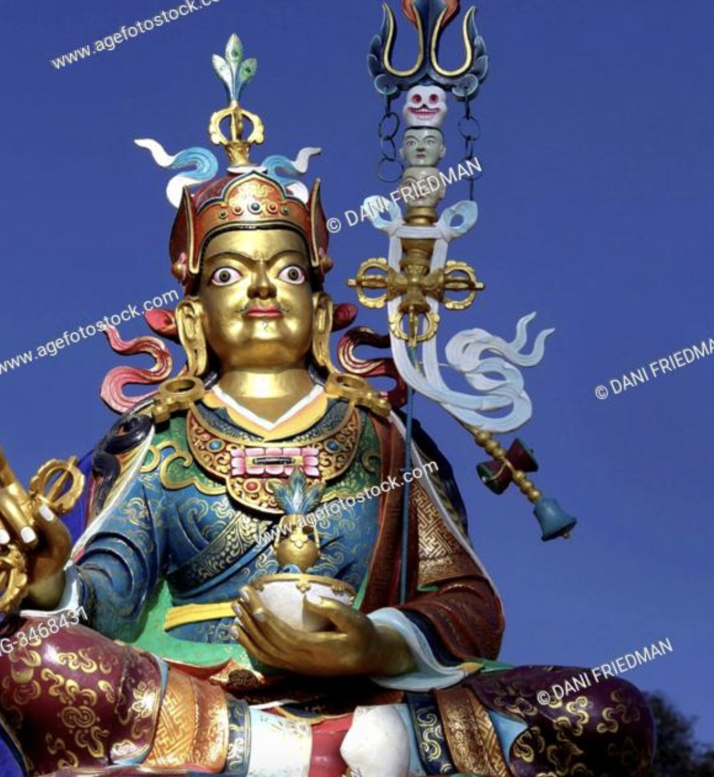

1. Trident
2. 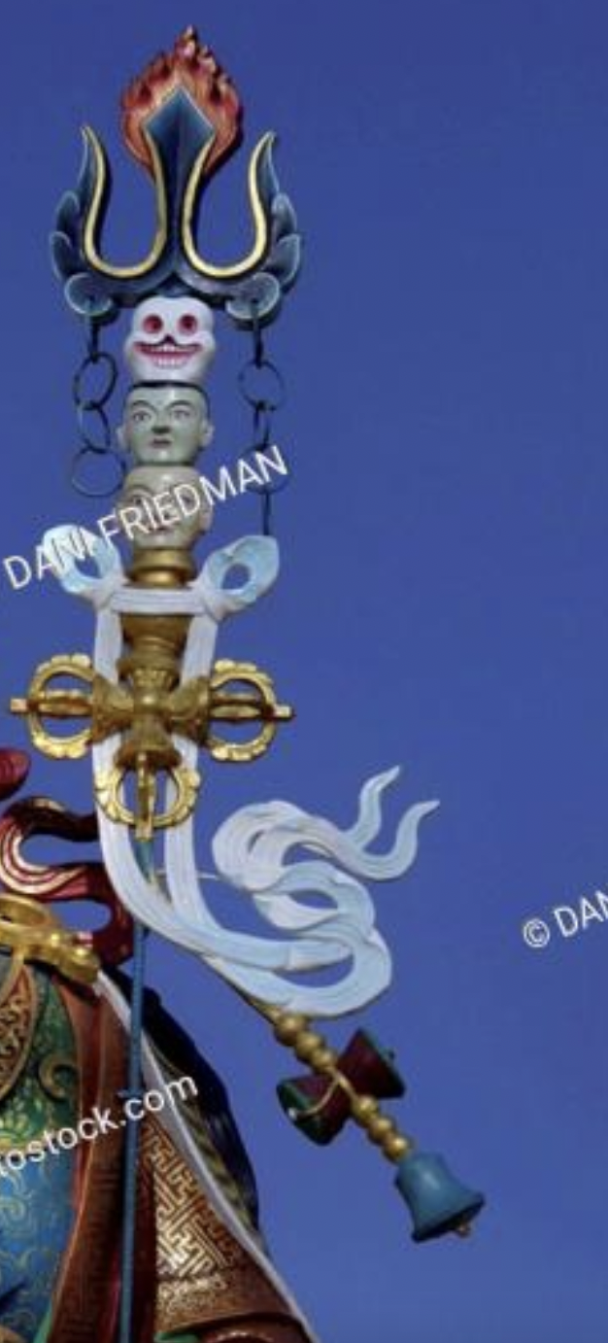Heads
3. Double Vajra
4. Tail

3. CLOAK

1. Make *BROWN* cloak IN ORIGINAL IMAGE INTO Maroon brocade as seen in the second figure below
2. *Insert same* Patterns as seen in *inner* blue robe photo above 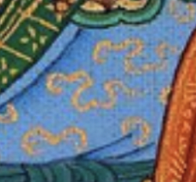

4. Robes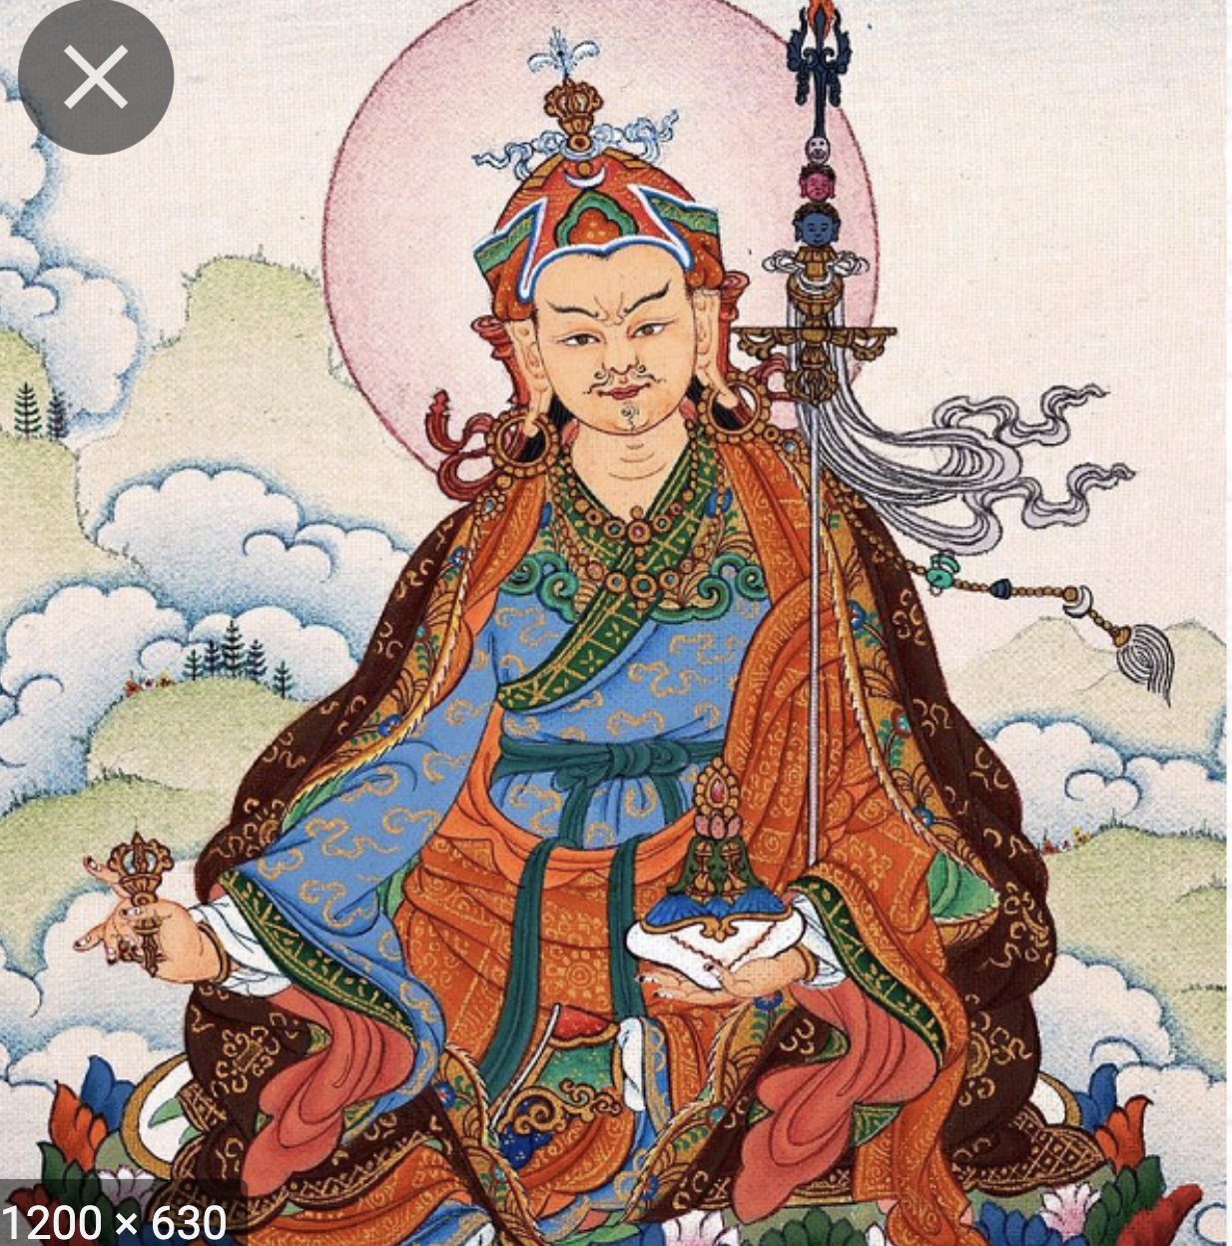

1. Outer
   1. *Replace* Orange/red color to *above photo*
2. Inner robes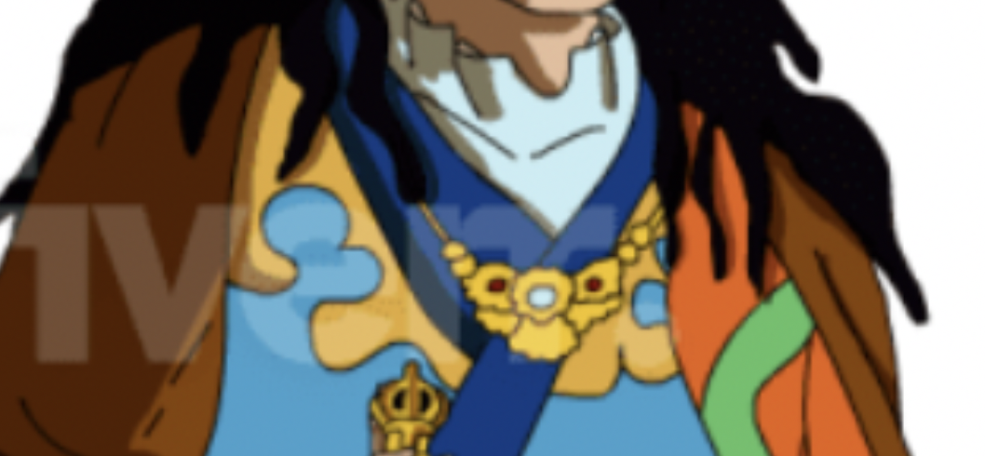
   1. *same patterns as darker blue inner robe as seen in reference photo above the original image photo.*
   2. Remove *irregular shape gold trim* resting on the top of the inner (*light blue*) robe surrounding the bejeweled gold necklace. (*Make light blue* robe (*dark blue) (samples from robe photos above OF THE PHOTO ABOVE ORIGINAL.)*
3. Innermost robes should be white including around the neck (currently light blue*).*
   1. White around his neck
   2. White sleeves
   3. Shadows (*removed from light blue area around neck)*
4. Sash
   1. changed to Dark blue *(sample) as seen of photo that is above original image*
5. Remove green line/trim/material

4. Feet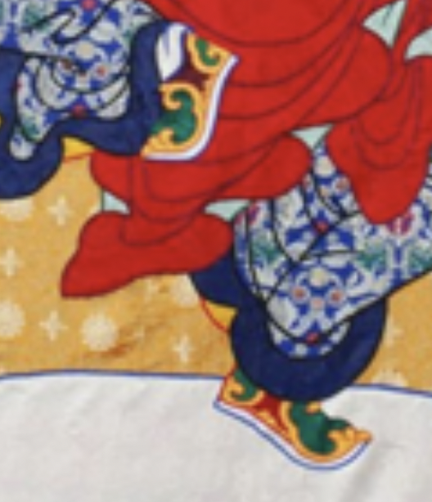

1. add shoes - Persian style as in these photos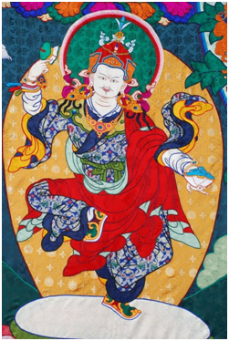
2. Change green area of these shoes to blue

5. Face & skin tone changes

1. MOUSTACHE & GOATEE like this
2. Remove *sideburn*s
3. Delineate *long hair flowing down back (like photo below)*
4. Eyebrows *(like photo below)*
5. Eyes like this photo
6. Change skin tone of ears, face, neck, and hands closer to photo

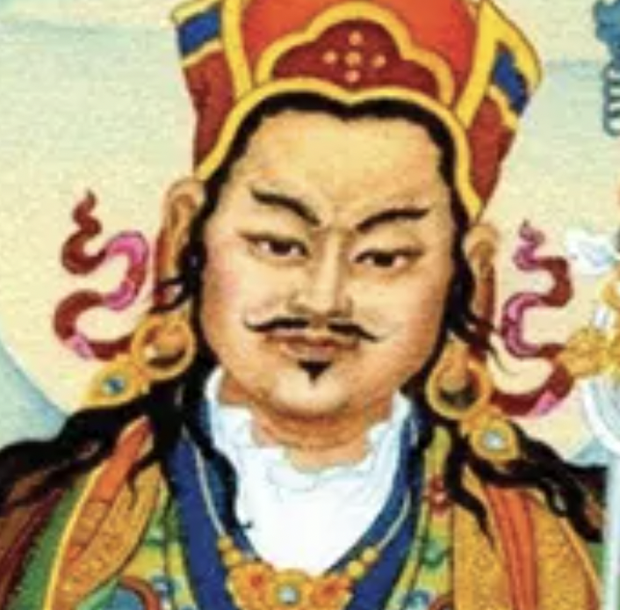

7. Earrings

1. Slight *Enlargement (similar to photo above)*
2. Change jewel to dark turquoise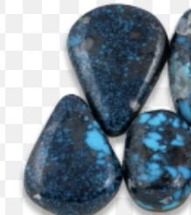

8. Necklace

1. Center jewel *(dark hued)* turquoise
2. Deep red hue rubies on either side 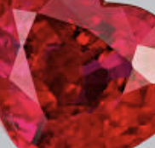
3. Same gold (*color)* as vajra 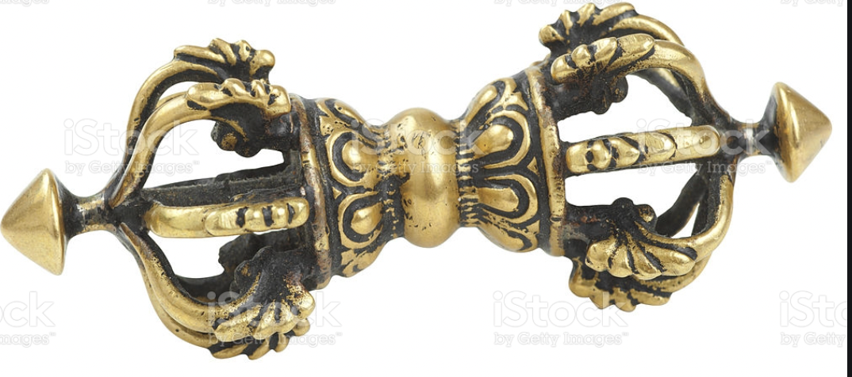

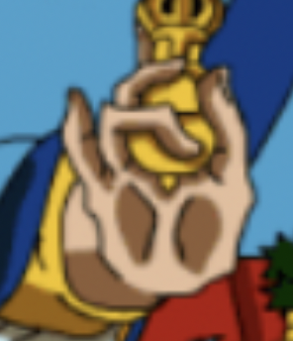9. Hand and fingers

1. Finger anatomy and positions normalized (*like photo above)*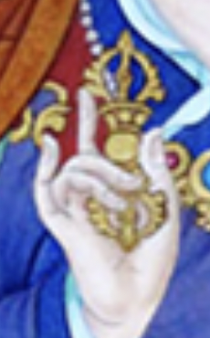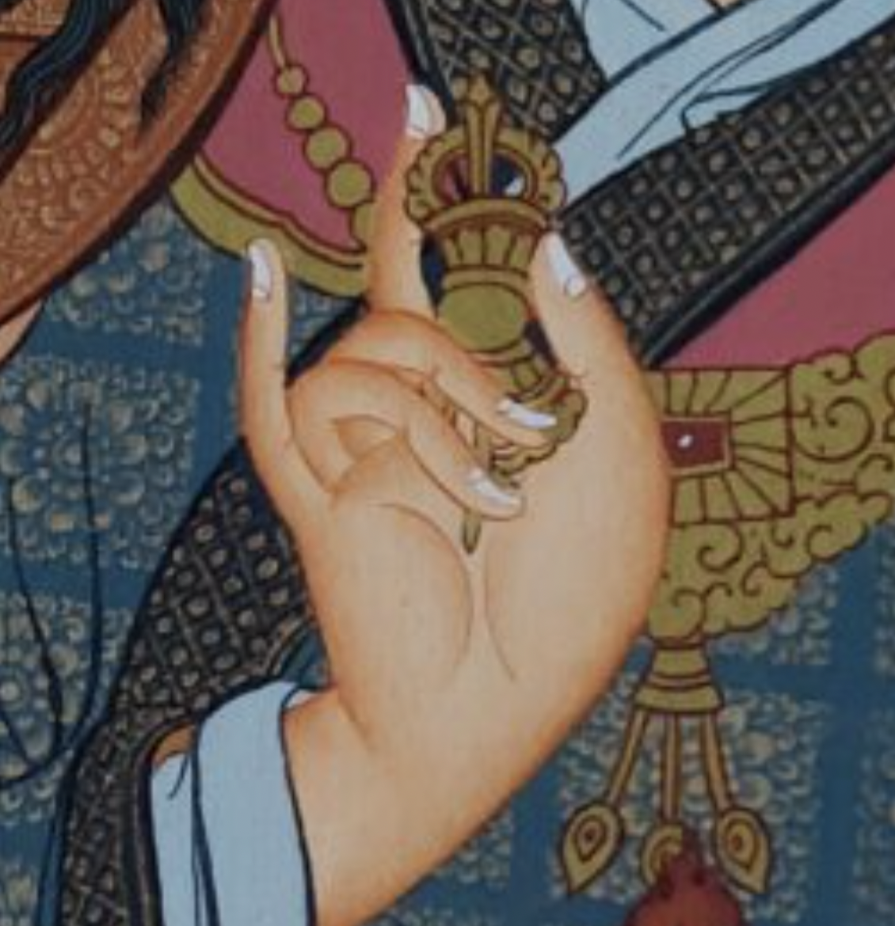
2. *Weird shadows on original image hand removed*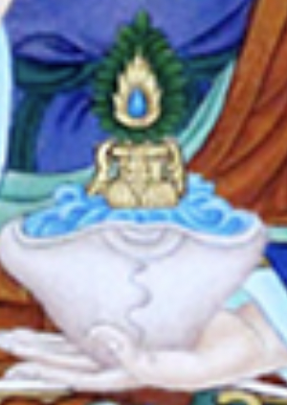

10. LEFT HAND HOLDING SKULL BOWL

1. Thumb normalization-*see example with photo right.*

b. Skullcup -*Replace with photo to the right of Long life vase with blue substance inside and gold long life vase with peacock feather.*

*Example Long Life Vase without Skullcup*

